Segment Collinearity

Definition
# Source: AI Source: Provided by: [Data Path: Persons Table -> ID Column: 1, Name_En Column: Motasem Essam] -> From: [ChatGPT] on [7/25/2026]
Segment Collinearity is a type of collinearity in which two or more line segments lie on the same supporting straight line.
For line segments $\overset{‾}{AB}$and $\overset{‾}{CD}$, they are collinear if there exists a single line $l$such that:
$$A,B,C,D∈l$$
The segments themselves do not have to touch or overlap. They can be separated while still being collinear.
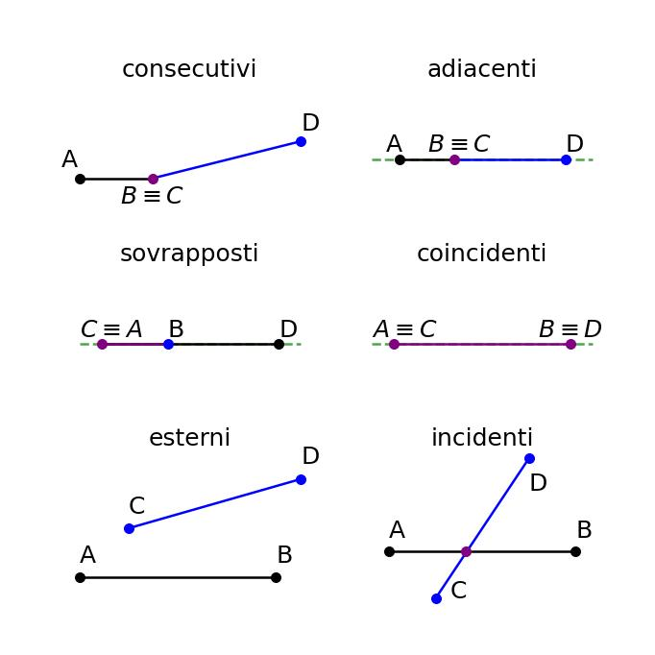
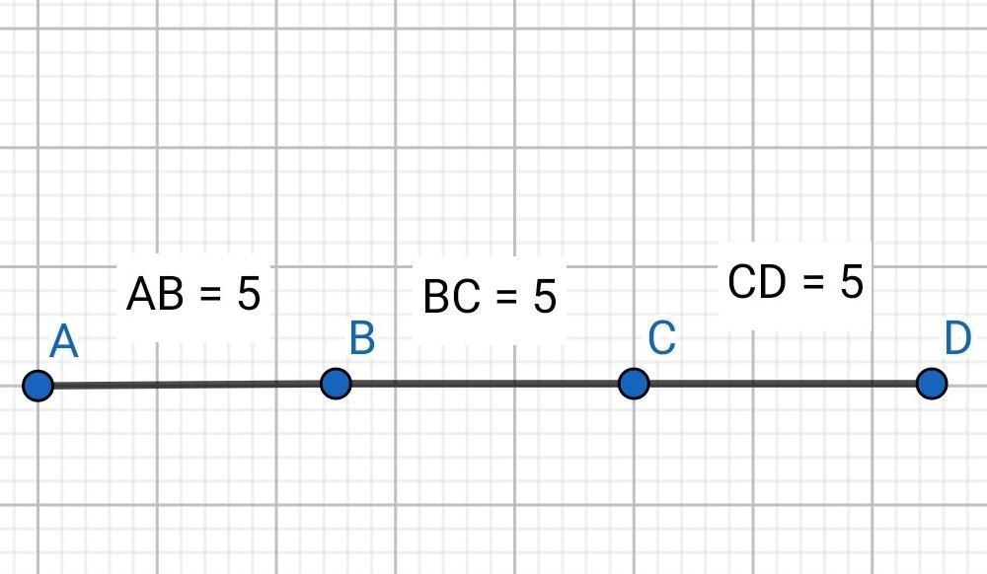
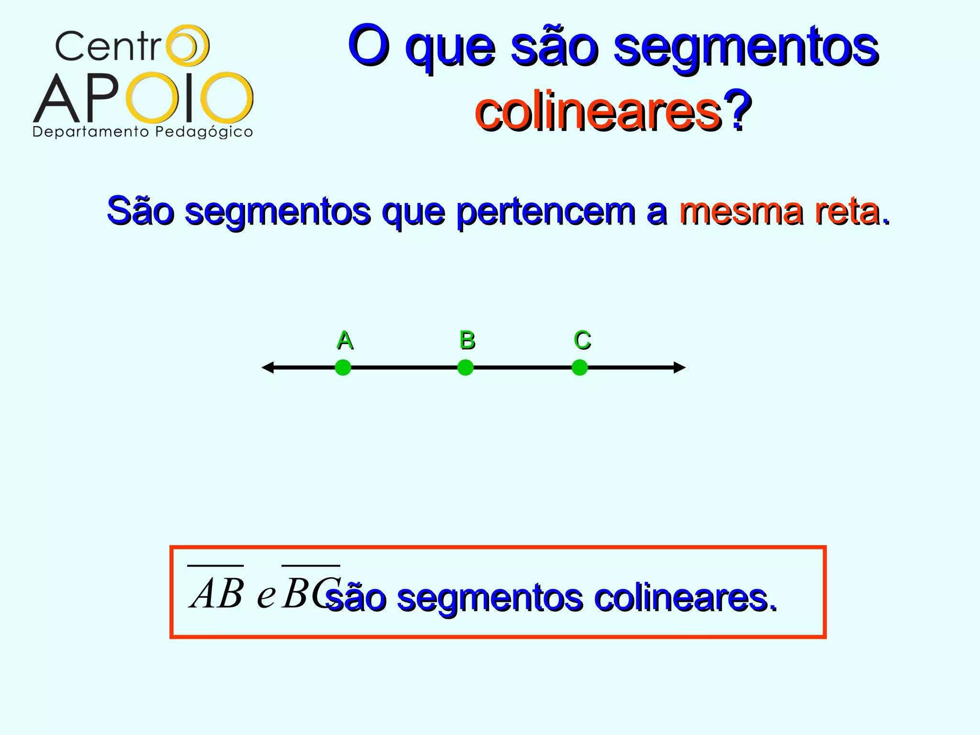
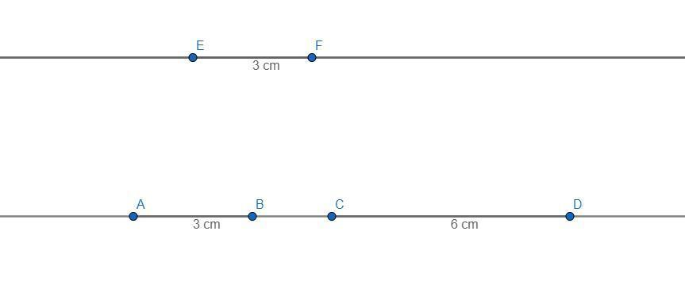
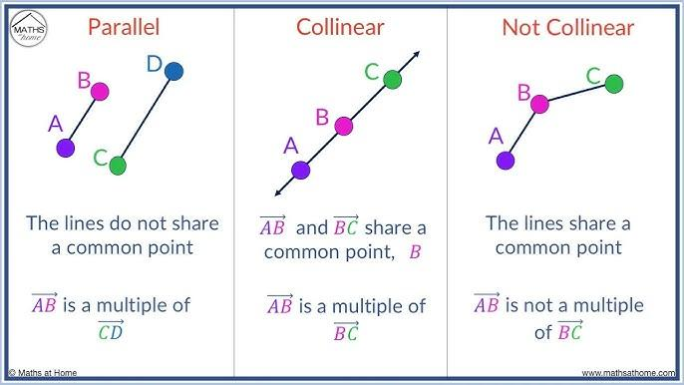

Purpose
# Source: AI Source: Provided by: [Data Path: Persons Table -> ID Column: 1, Name_En Column: Motasem Essam] -> From: [ChatGPT] on [7/25/2026]
Segment collinearity is used to:
- Determine whether line segments lie on the same straight line.
- Analyze the positional relationship between multiple segments.
- Identify separated, touching, overlapping, and coincident segments.
- Study segment lengths and segment addition.
- Analyze geometric figures containing multiple aligned segments.
- Establish relationships between points and segments.

Fundamental Concept
# Source: AI Source: Provided by: [Data Path: Persons Table -> ID Column: 1, Name_En Column: Motasem Essam] -> From: [ChatGPT] on [7/25/2026]
The defining property is that the supporting lines of the segments are the same line.
For:
$$\overset{‾}{AB}$$
and:
$$\overset{‾}{CD}$$
segment collinearity means:
$$\boxed{A,B,C,D∈l}$$
for one common line $l$.
Conceptually:
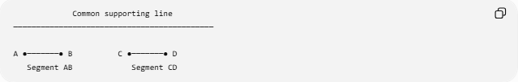
Common supporting line
────────────────────────────────────────────

A ●───────● B C ●───────● D
Segment AB Segment CD
The segments are separated, but they are still collinear.

Types of Segment Collinearity
# Source: AI Source: Provided by: [Data Path: Persons Table -> ID Column: 1, Name_En Column: Motasem Essam] -> From: [ChatGPT] on [7/25/2026]
The positional relationship between collinear segments can be classified as:
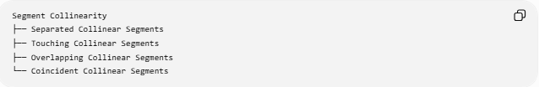
Segment Collinearity
├── Separated Collinear Segments
├── Touching Collinear Segments
├── Overlapping Collinear Segments
└── Coincident Collinear Segments

1. Separated Collinear Segments
# Source: AI Source: Provided by: [Data Path: Persons Table -> ID Column: 1, Name_En Column: Motasem Essam] -> From: [ChatGPT] on [7/25/2026]
Two segments lie on the same line but have a positive gap between them.
A ●────● B C ●────● D
<── gap ──>
For example:
$$\overset{‾}{AB}=\left[1 , 4\right]$$
and:
$$\overset{‾}{CD}=\left[7 , 10\right]$$
The gap is:
$$g=7-4=3$$
Therefore, the segments are collinear and separated.

2. Touching Collinear Segments
# Source: AI Source: Provided by: [Data Path: Persons Table -> ID Column: 1, Name_En Column: Motasem Essam] -> From: [ChatGPT] on [7/25/2026]
Two segments lie on the same line and meet at exactly one endpoint.
A ●────────● B=C ────────● D
For example:
$$\overset{‾}{AB}=\left[1 , 5\right]$$
and:
$$\overset{‾}{CD}=\left[5 , 9\right]$$
The segments touch at:
$$B=C$$
and their gap is:
$$g=0$$
They do not overlap over a positive length.

3. Overlapping Collinear Segments
# Source: AI Source: Provided by: [Data Path: Persons Table -> ID Column: 1, Name_En Column: Motasem Essam] -> From: [ChatGPT] on [7/25/2026]
Two collinear segments share a portion of their lengths.
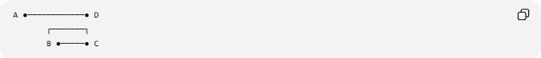
A ●────────────● D
┌───────┐
B ●─────● C
For example:
$$\overset{‾}{AB}=\left[1 , 8\right]$$
and:
$$\overset{‾}{CD}=\left[5 , 11\right]$$
Their common portion is:
$$\left[5 , 8\right]$$
Therefore, they are overlapping collinear segments.

4. Coincident Collinear Segments
# Source: AI Source: Provided by: [Data Path: Persons Table -> ID Column: 1, Name_En Column: Motasem Essam] -> From: [ChatGPT] on [7/25/2026]
Two segments are coincident when they occupy exactly the same set of points.
A ●────────────────● B
C ●────────────────● D
If:
$$\overset{‾}{AB}=\overset{‾}{CD}$$
then every point belonging to one segment also belongs to the other.
For example:
$$\overset{‾}{AB}=\left[2 , 8\right]$$
and:
$$\overset{‾}{CD}=\left[2 , 8\right]$$
Therefore:
$$\boxed{\overset{‾}{AB}=\overset{‾}{CD}}$$

Interval Representation
# Source: AI Source: Provided by: [Data Path: Persons Table -> ID Column: 1, Name_En Column: Motasem Essam] -> From: [ChatGPT] on [7/25/2026]
Collinear segments can conveniently be represented as intervals on a common coordinate axis.
Let:
$$S_{1}=\left[a , b\right]$$
and:
$$S_{2}=\left[c , d\right]$$
with:
$$a≤b, c≤d$$
Their positional relationship can be determined from their endpoints.
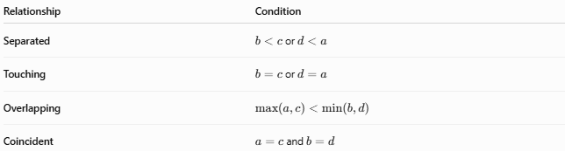
Relationship | Condition
Separated | $b<c$or $d<a$
Touching | $b=c$or $d=a$
Overlapping | $$max⁡\left(a , c\right)<min⁡\left(b , d\right)$$
Coincident | $a=c$and $b=d$

Collinearity Test
# Source: AI Source: Provided by: [Data Path: Persons Table -> ID Column: 1, Name_En Column: Motasem Essam] -> From: [ChatGPT] on [7/25/2026]
To determine whether two segments are collinear, check whether all of their endpoints lie on one common straight line.
For:
$$\overset{‾}{AB}$$
and:
$$\overset{‾}{CD}$$
we require:
$$A,B,C,D∈l$$
for the same line $l$.
If the segments have four endpoints, checking that the endpoints lie on the same supporting line establishes segment collinearity.

Coordinate Example
# Source: AI Source: Provided by: [Data Path: Persons Table -> ID Column: 1, Name_En Column: Motasem Essam] -> From: [ChatGPT] on [7/25/2026]
Consider:
$$A\left(1 , 3\right), B\left(4 , 3\right)$$
and:
$$C\left(7 , 3\right), D\left(10 , 3\right)$$
All four points satisfy:
$$y=3$$
Therefore:
$$A,B,C,D∈l$$
where:
$$l:y=3$$
Thus:
$$\boxed{\overset{‾}{AB}\text{ and }\overset{‾}{CD}\text{ are collinear}}$$
Since:
$$4<7$$
the segments are also separated.
Their gap is:
$$g=7-4=3$$

Segment Collinearity and Point Collinearity
# Source: AI Source: Provided by: [Data Path: Persons Table -> ID Column: 1, Name_En Column: Motasem Essam] -> From: [ChatGPT] on [7/25/2026]
Segment collinearity is directly related to point collinearity.
For:
$$\overset{‾}{AB}$$
and:
$$\overset{‾}{CD}$$
the segments are collinear when their endpoints:
$$A,B,C,D$$
are all collinear.
Therefore:
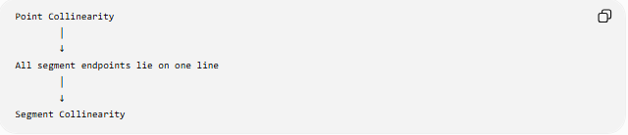
Point Collinearity
│
↓
All segment endpoints lie on one line
│
↓
Segment Collinearity

Segment Collinearity vs. Parallel Segments
# Source: AI Source: Provided by: [Data Path: Persons Table -> ID Column: 1, Name_En Column: Motasem Essam] -> From: [ChatGPT] on [7/25/2026]
These concepts should not be confused.
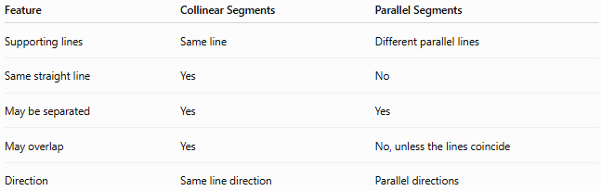
Feature | Collinear Segments | Parallel Segments
Supporting lines | Same line | Different parallel lines
Same straight line | Yes | No
May be separated | Yes | Yes
May overlap | Yes | No, unless the lines coincide
Direction | Same line direction | Parallel directions
For example:
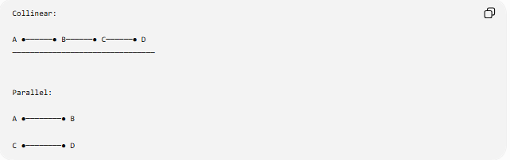
Collinear:

A ●──────● B──────● C──────● D
────────────────────────────────

Parallel:

A ●────────● B

C ●────────● D
The first pair lies on one supporting line. The second pair lies on different parallel lines.

Segment Collinearity vs. Coincidence
# Source: AI Source: Provided by: [Data Path: Persons Table -> ID Column: 1, Name_En Column: Motasem Essam] -> From: [ChatGPT] on [7/25/2026]
Collinearity only means that the segments lie on the same supporting line.
Coincidence means that they occupy exactly the same points.
Therefore:
$$\boxed{\text{Coincident segments are collinear}}$$
but:
$$\boxed{\text{Collinear segments are not necessarily coincident}}$$
For example, separated segments are collinear but not coincident.

Segment Collinearity vs. Overlap
# Source: AI Source: Provided by: [Data Path: Persons Table -> ID Column: 1, Name_En Column: Motasem Essam] -> From: [ChatGPT] on [7/25/2026]
Overlap is a possible positional relationship between collinear segments.
For example:
A ●────────────────● D
B ●────● C
The segments are:
- collinear,
- overlapping,
- not coincident.
Thus, these concepts should remain separate in your taxonomy.

Relationship to Segment Addition
# Source: AI Source: Provided by: [Data Path: Persons Table -> ID Column: 1, Name_En Column: Motasem Essam] -> From: [ChatGPT] on [7/25/2026]
When several points are ordered along the same line, segment lengths can be added.
For:
A ●──── B ●──── C ●──── D
the following relationships hold:
$$AB+BC=AC$$
and:
$$AC+CD=AD$$
Therefore:
$$AB+BC+CD=AD$$
This is an important consequence of having multiple points on the same supporting line.

Important Properties
# Source: AI Source: Provided by: [Data Path: Persons Table -> ID Column: 1, Name_En Column: Motasem Essam] -> From: [ChatGPT] on [7/25/2026]
- Collinear segments share the same supporting line.
- Their endpoints must lie on one common straight line.
- Collinear segments do not have to touch.
- Collinear segments may be separated by a positive gap.
- Collinear segments may touch at an endpoint.
- Collinear segments may partially overlap.
- Collinear segments may be coincident.
- Coincident segments are a special case of collinear segments.
- Parallel segments are generally not collinear because their supporting lines are different.
- Multiple collinear segments can be analyzed using one-dimensional interval relationships.

Key Points
# Source: AI Source: Provided by: [Data Path: Persons Table -> ID Column: 1, Name_En Column: Motasem Essam] -> From: [ChatGPT] on [7/25/2026]
- Segment Collinearity means two or more line segments lie on the same supporting line.
- All endpoints of the segments must lie on that common line.
- Collinear segments can be separated, touching, overlapping, or coincident.
- A positive gap does not prevent collinearity.
- Coincident segments are collinear, but separated collinear segments are not coincident.
- Parallel segments generally have different supporting lines and therefore are not collinear.
- Segment collinearity connects point collinearity with the study of relationships between line segments.

Conclusion
# Source: AI Source: Provided by: [Data Path: Persons Table -> ID Column: 1, Name_En Column: Motasem Essam] -> From: [ChatGPT] on [7/25/2026]
Segment Collinearity describes the alignment of two or more line segments along one common straight line. It is an extension of point collinearity from individual points to finite linear objects and provides the foundation for analyzing separated, touching, overlapping, and coincident line segments.
Would you like to continue with line-object collinearity or compare segment collinearity with parallelism?

